A Business Central Consultant’s Copilot Journey
  - Trying Copilot in BC
Author: Kim Dallefeld, MVP, MCT, MCP

Now that we’ve seen the prompts in BC, let’s try using Copilot in a real world situation.
Using the ‘ask’ feature, I typed, ‘show customer invoices past due’ and the results gave me a list of open unposted sales invoices. Since this was not what I wanted, I asked ‘ what customer invoices are past due’ and the results were:
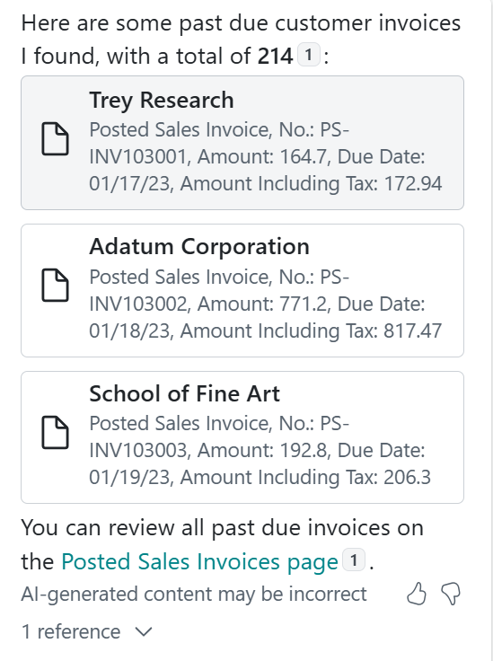
Results looked good, but I wanted to dig deeper and validate the results so I clicked on ‘1 reference’. WOW, a list of all posted sales invoices in Analysis Mode were displayed. This made me a little nervous because though I knew that the invoice had the due date, that’s not normally where I would expect to look for unpaid invoices. And then I saw that posted sales invoices have a field ‘remaining amount’ which is exactly what I would expect from the customer ledger. I did not want to see all the paid invoices so I added a filter for not equal to zero and done!
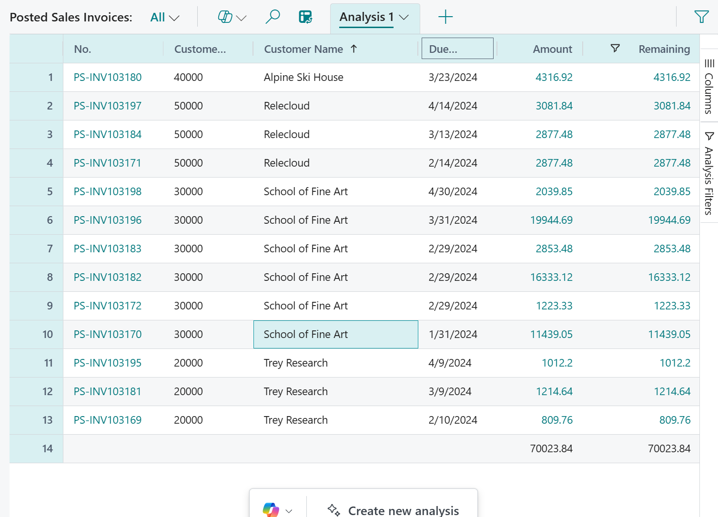

I was super happy with the results but then I thought, could I get this analysis already without the zero amounts and sorted highest to lowest? I was confident that asking the right question would get me the answer.
I asked Copilot to sort the data with highest remaining amount first and nothing changed on the page but the tiles did change:
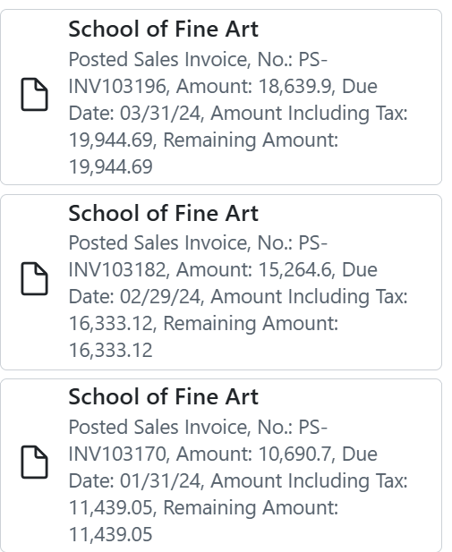
When you click on any tile, the posted sales invoice opens. Learning to ask the right question with the relevant details and its amazing what answers you will receive.

