A Business Central Consultant’s Copilot Journey
  - Finding Copilot in BC
Author: Kim Dallefeld, MVP, MCT, MCP
As I started trying to learn how Copilot could assist me in Business Central, I decided to explore what I could with the prompts already in BC.
Below is the top right of the Business Central user interface

Throughout the various pages in Business Central, as you more from field to field, you might see ‘stars’….
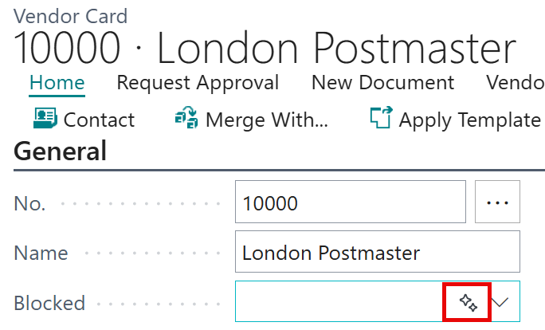

The Analysis Mode feature has Copilot options:
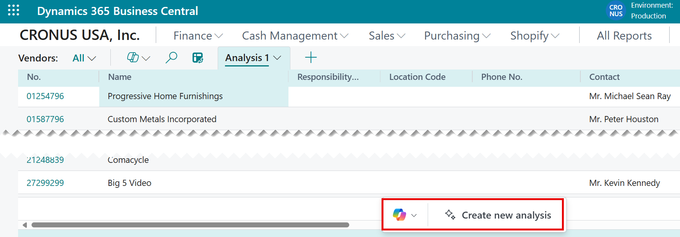

But how do you take advantage of these? I thought I would try to find out what invoices were past due. So from the customer list, I used the Copilot option from the Role Center (first one shown above) and I received the following:
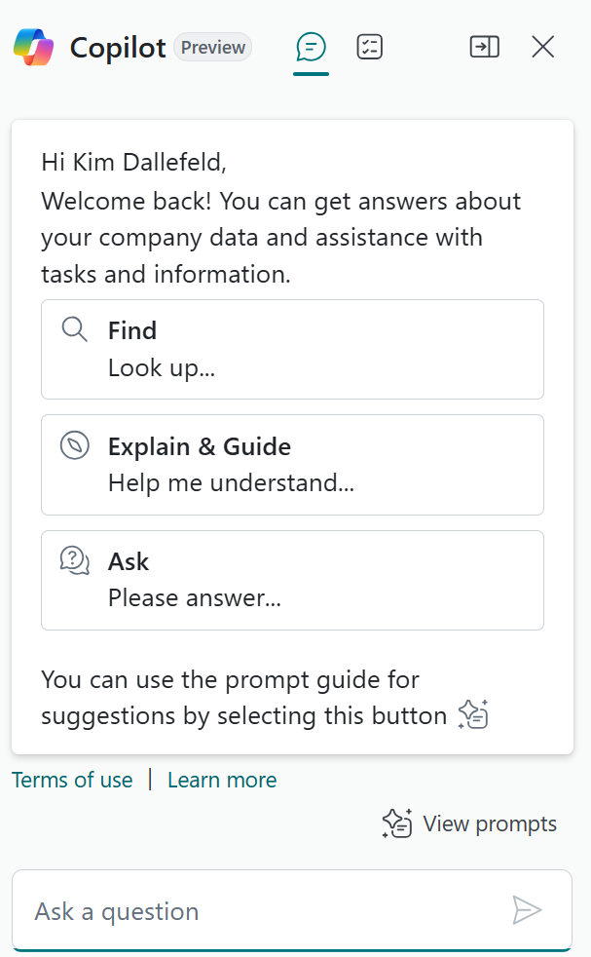

I tried each option, suggest you review these until you are comfortable which their particular functions. For what I wanted, I decided to ‘Ask a question; using the prompt near the bottom of the window. More in next blog.

