30 Problems/30 Fixes - Tip #30 Excel Layouts

Kim Dallefeld, MCP, MCT, MCP

There are Excel Preview reports what’s the difference between that an Excel Layouts?
Excel Previews are report only designed to be an Excel download with build-in filters. They can be run with filters and date ranges.
Excel Layouts let you take a standard report and build a different report and your only visuals. You can add from other sources and make modifications. And you can same the changed report back into Business Central for anyone to utilize.
Example #1 – Report from BC
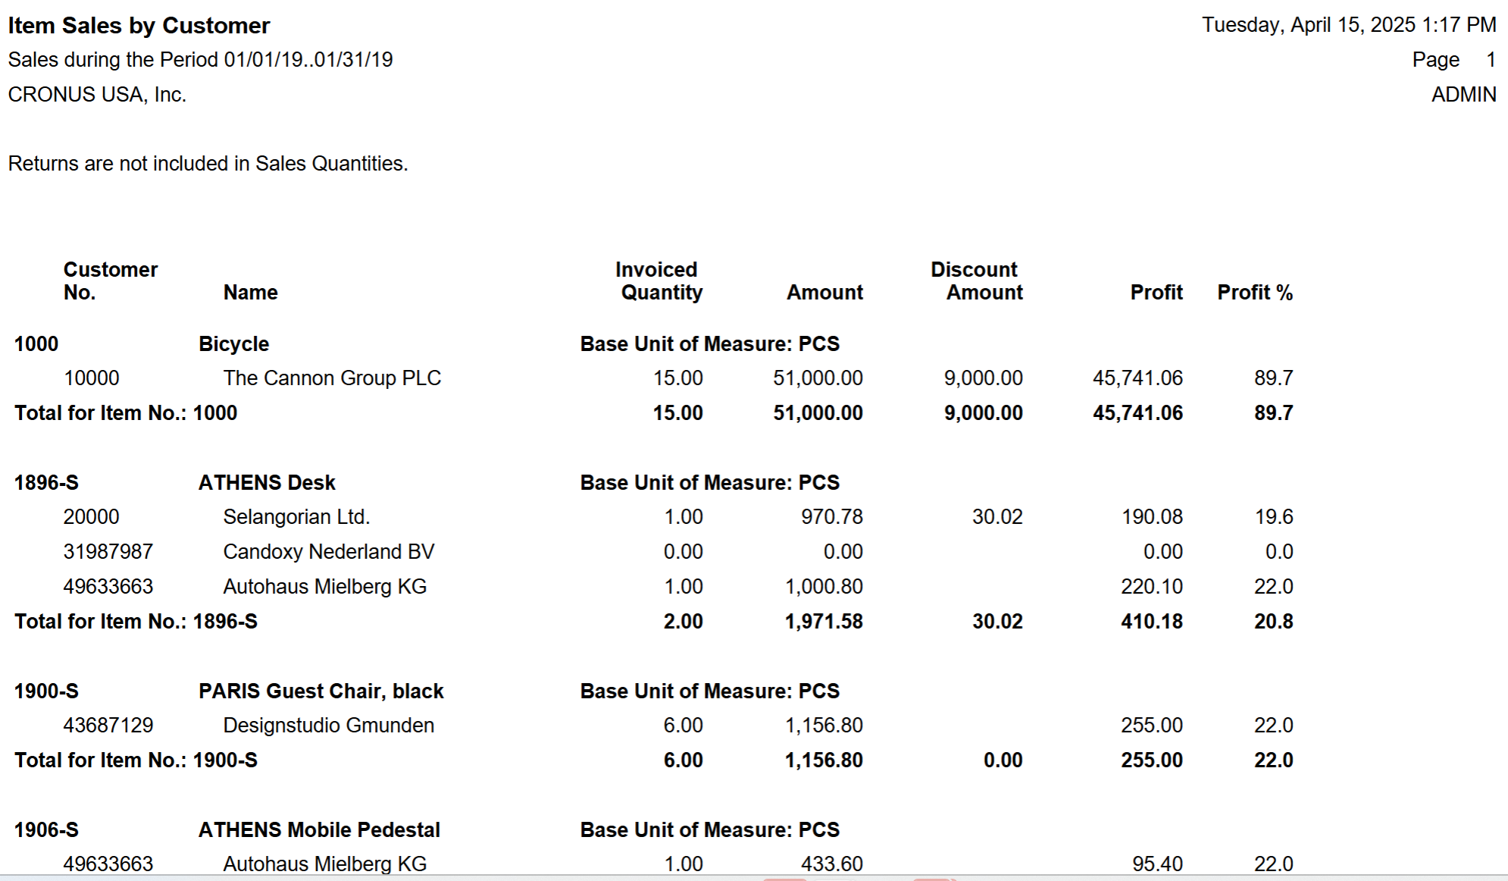
Same report in Excel with a Pivot table and chart.
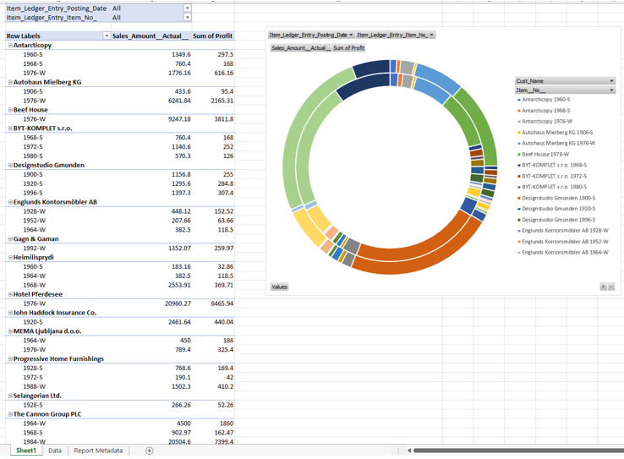
Example #2 – Report from BC
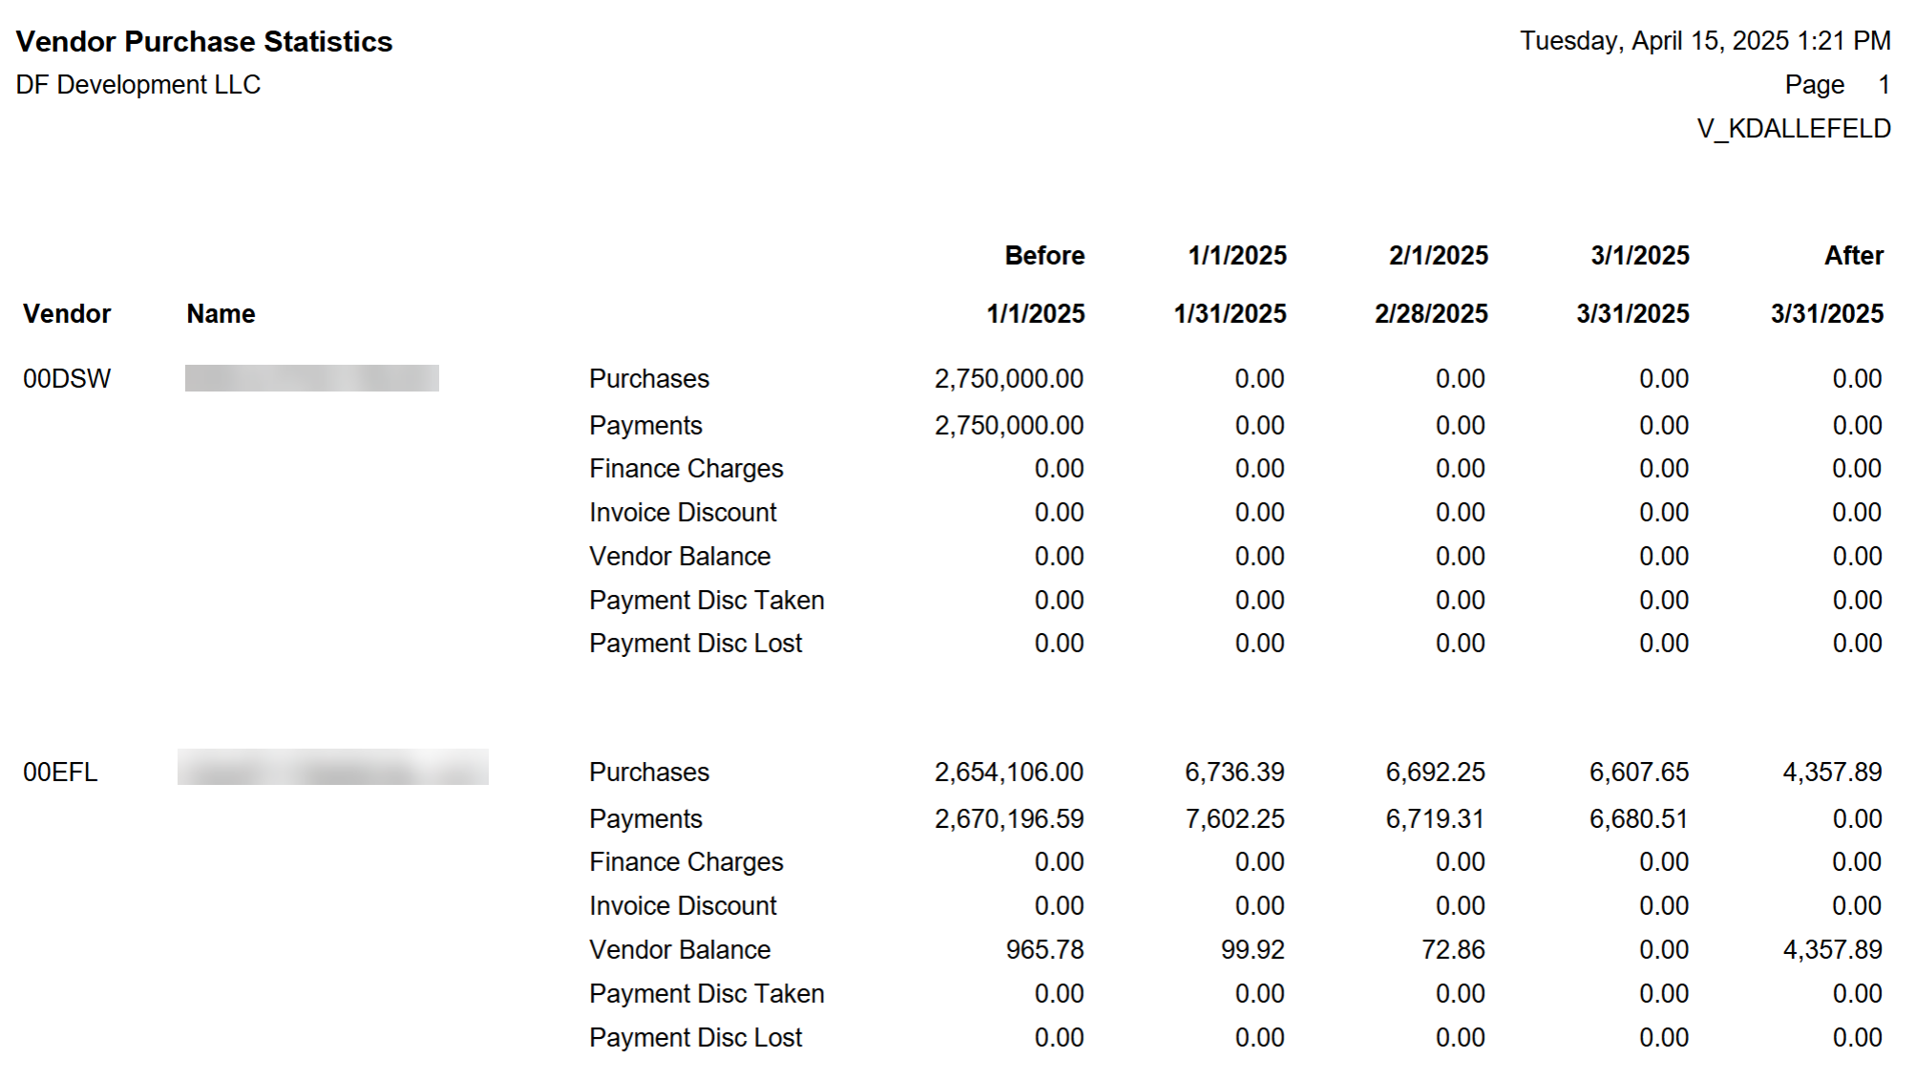
Report modified, date headings converted, totals added.
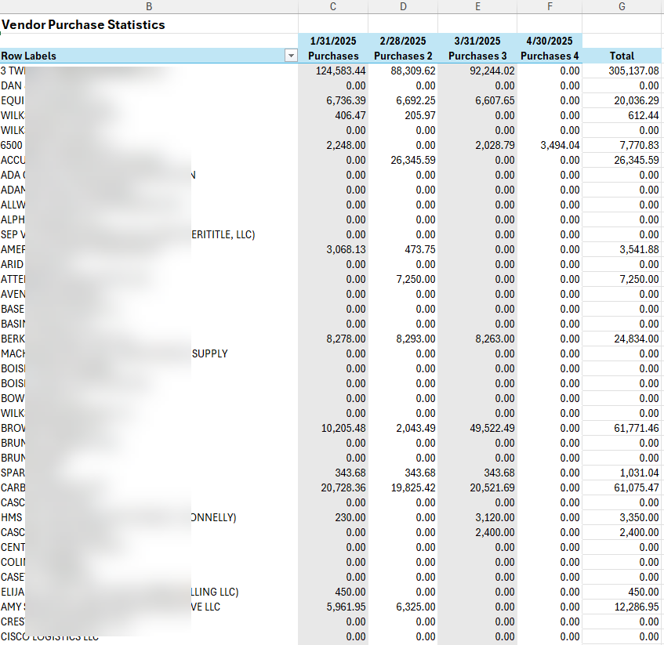
So much that you can do, and reuse and share!

