30 Problems/30 Fixes - Tip #29 Analysis Mode

Kim Dallefeld, MCP, MCT, MCP

Excel and Saved Views are nice but I need to summarize, change columns, I just need more!
Recommendation:
Analyze Mode

Here’s an example of using Analyze Mode on Posted Sales Invoices, starting with the default screen.
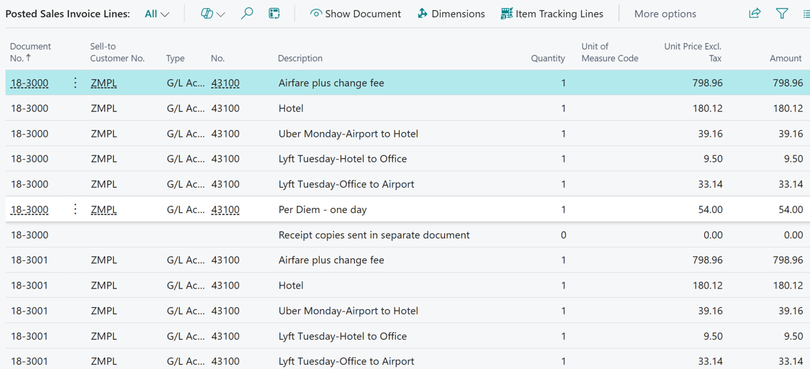
Next an Analysis sorted and groups by sell-to customer:
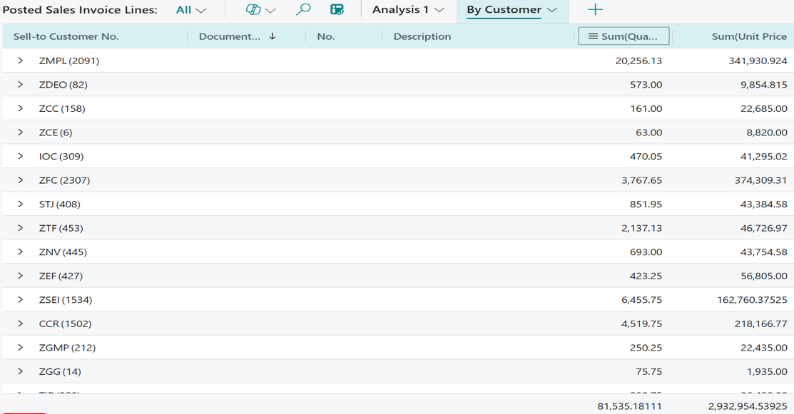
An you can expand any grouping to get more detail.
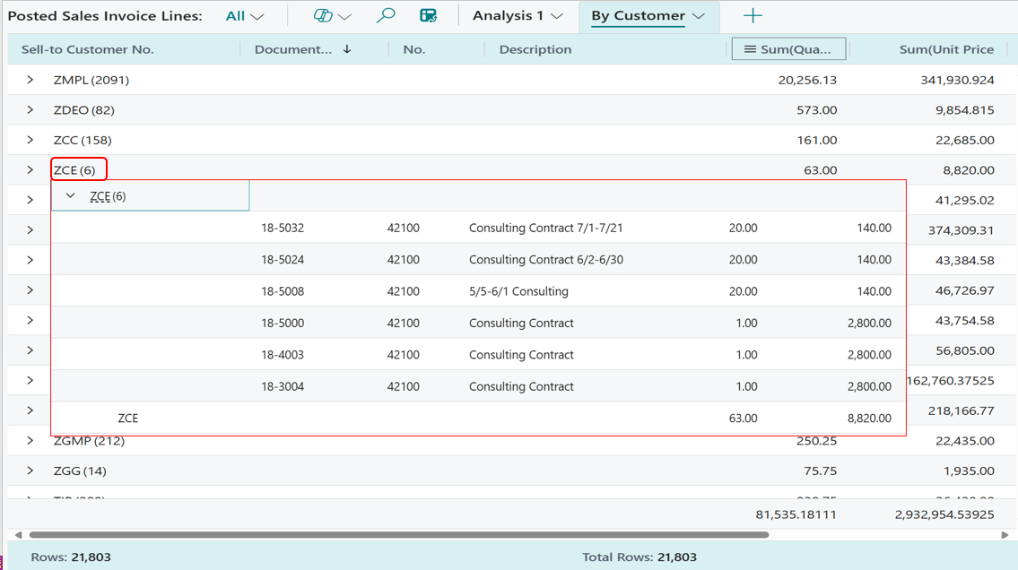
These views are exportable to Excel and with version 26.2 you can add fields from associated tables. See video blog on this specific topic at kimdandnavbc.com and on dynamiccommunities.com

