30 Problems/30 Fixes - Tip #28 Saved Views

Kim Dallefeld, MCP, MCT, MCP

Filtering on the same data, day after day, week after week or month after month…..Stop it! Start using Saved Views!
Recommendation:
Save that filter as a Saved View! You can have as many as you want.

Example of a Saved View showing Invoices Only
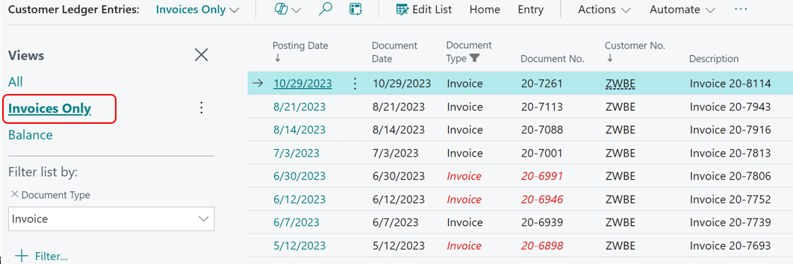

Hiding the FilterPane and yet using a Saved view anyway! You can see more fields!
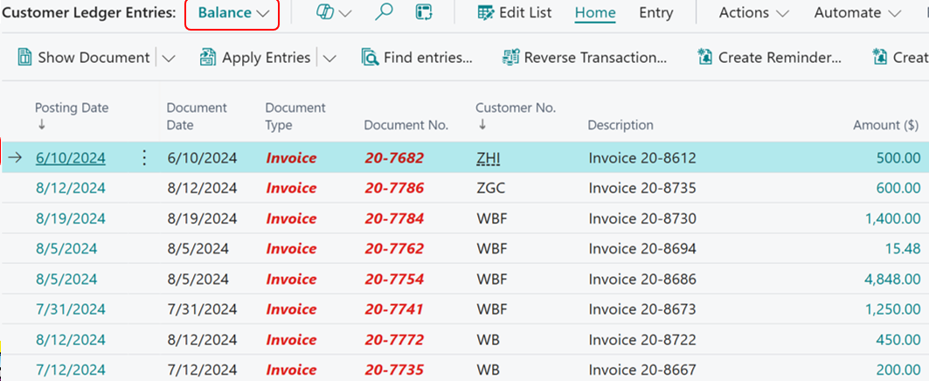
The more often that you do NOT have to scroll left to right and back again, the more efficient you are and thus the less tired by use of your mouse and computer!

