30 Problems/30 Fixes - Tip #27 Open in Excel

Kim Dallefeld, MCP, MCT, MCP

Just want the data from Business Central so that you can analysis or build a report…..
Recommendation:
Use the Open in Excel feature
BC does respect the filters that you have applied so be aware.
BC only reports the columns that you are displaying, if you need more…first try to personalize and add the field. If that does not succeed you will need to add the field through the Profile.
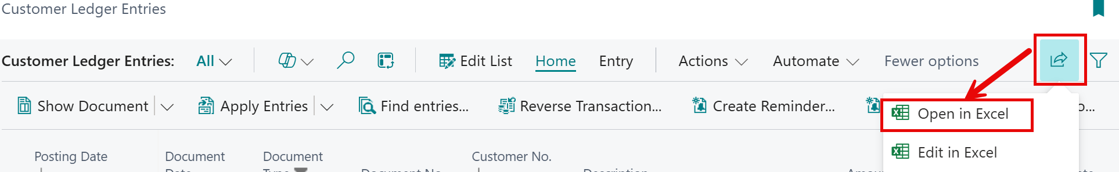
Love this feature, but I am having a love affair with Analysis Mode also.

