30 Problems/30 Fixes - Tip #26 Shortcuts

Kim Dallefeld, MCP, MCT, MCP

Back in NAV, I used shortcuts or F-keys and they saved so much time….I need them back!
Recommendation:
They are there, the particulate ‘f’ keys are different but they are there!
Find them by choosing the ‘?’ in the top right corner, scroll down to the keyboard shortcuts. (first picture)
This will take you to Microsoft documentation where you will see the second picture. You can open the thumbnail picture and download the file.
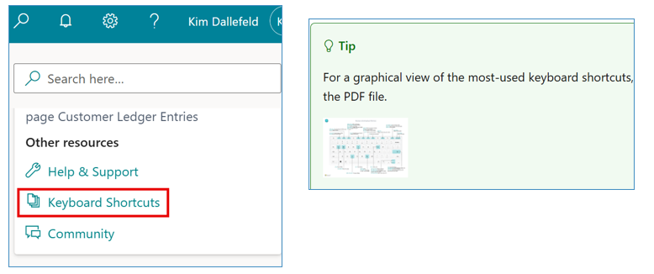
Print the file, laminate it and use it to learn or re-learn the shortcut keys!
These will save you time and make you more efficient!

