30 Problems/30 Fixes - Tip #24 Badge

Kim Dallefeld, MCP, MCT, MCP

It is so hard to know which company that I’m working in, is there a solution?
Recommendation:
Yes, in Company Information, set a Company Badge

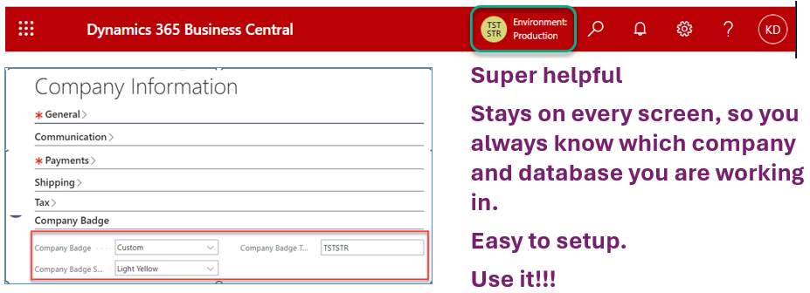
- In Company Information
  - Set Company Badge to Custom
  - Pick a Badge Color
  - Enter up to 6 characters to define the company
- Close Company Information
  - System reset and displays the badge top right (shown above as yellow circle)

Note: production badges are circle badges and sandbox badges are square badges.
Bonus: you can copy emogi into your Badge; here's an example...


