30 Problems/30 Fixes - Tip #23 Peeks

Kim Dallefeld, MCP, MCT, MCP

What is a ‘peek’?
One or two clicks to get to additional data, are simply called peeks.
Here’s a couple of examples:
- A field has a dotted line under a value. Clicking on the number gets you the first small screen and then clicking on the words with the solid underline gives you the second screen.
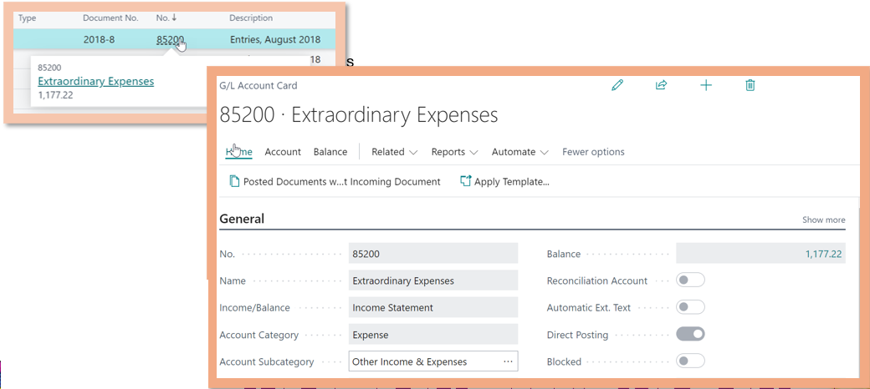

- Drilling on a field to get a list, you see a ‘show details’ option and clicking on those words, the associated record is displayed.
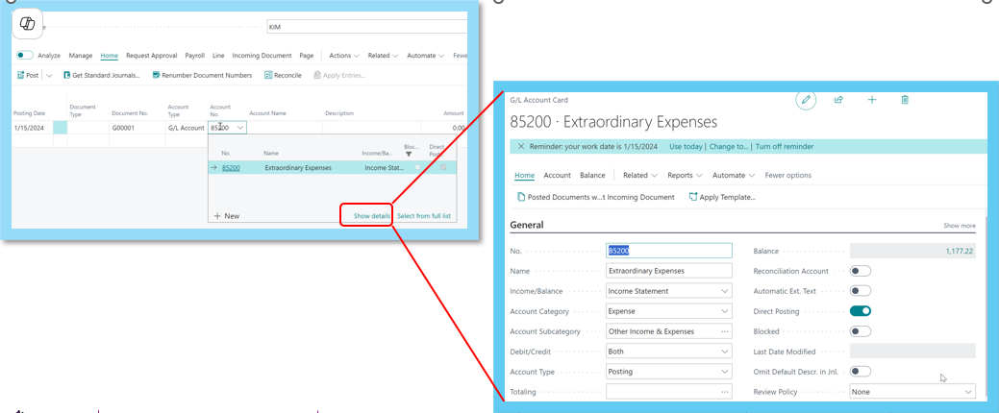

Shortcuts, peeks, whatever you call them, easy ways to get to more data without having to leave the screen you are working on to see additional data.

