30 Problems/30 Fixes - Tip #20 Dates

Kim Dallefeld, MCP, MCT, MCP
I enter dates constantly, is there anything that can improve efficiency for date?
Recommendation:
ABSOLUTELY! Here’s a few examples.
In the example screenshots below, note the first Posting Date or Date Filter as it will have the example of what to enter and then the Posting Date or Date Filter as interpreted by BC.
#1 Favorite is 't' for Today!
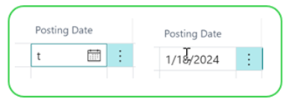
Super useful for accountants working in last month; use ‘w’ for workdate
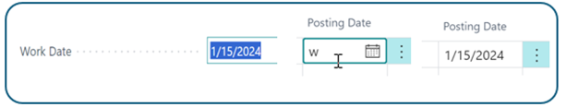
Working in the current month, just enter the date or month and date as shown in the first two examples below.
You never have to enter separators such as slashes ‘/’ or the year if working in the current year.
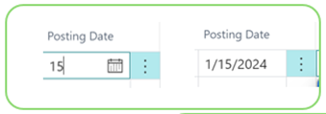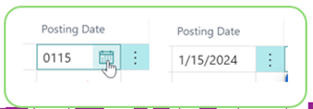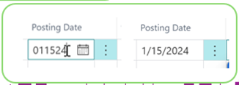
Date ranges are super easy using shortcuts for your accounting periods
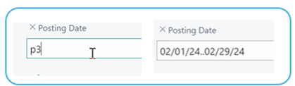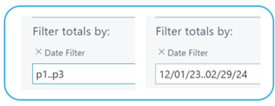
These simple tips can say you lots of key strokes.

