30 Problems/30 Fixes - Tip #19 Payment Tolerance

Kim Dallefeld, MCP, MCT, MCP
Sometimes my customer’s payment is for a wrong amount, typically a small amount, isn’t there an easy way to just write this off at the time of entering the cash receipt?
Recommendations:
Yes, it’s called Payment Tolerance

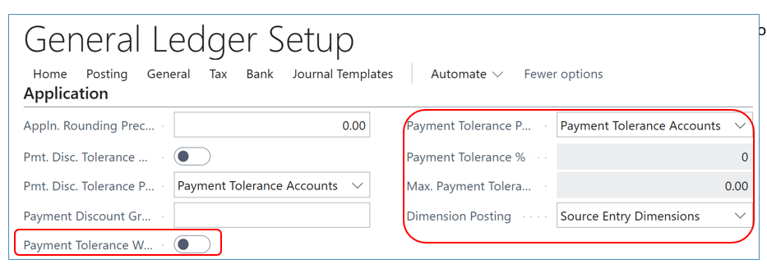

When your deposit or cash receipts journal is posted, BC will credit the customer for the payment and the tolerance difference, debit the bank for the actual amount paid and debit the customer posting group payment tolerance account.
Note: the amount of difference must fall within the tolerance parameters defined in General Ledger Setup; fields highlighted above.
This saves you time and accurately handles the payment accounting for the difference.

