30 Problems/30 Fixes - Tip #16 Deferrals

Kim Dallefeld, MCP, MCT, MCP

Recurring journals to record expenses for prepaids such as insurance is really helpful. However it would be nice if when processing the invoice for anything prepaid that Business Central would just handle all the monthly expenses. Isn’t there an easy way to handle versus remembering to post a recurring journal each month?
Recommendation:
Deferrals to the rescue! Not only for expenses but for revenue or any journal. Enter and post your document and you are done. All entries for all the months are posted so you don’t have to remember to post a journal each month.
Example for a prepaid insurance purchase invoice, checking the schedule that will post. There are many options for how and when your postings are handled.

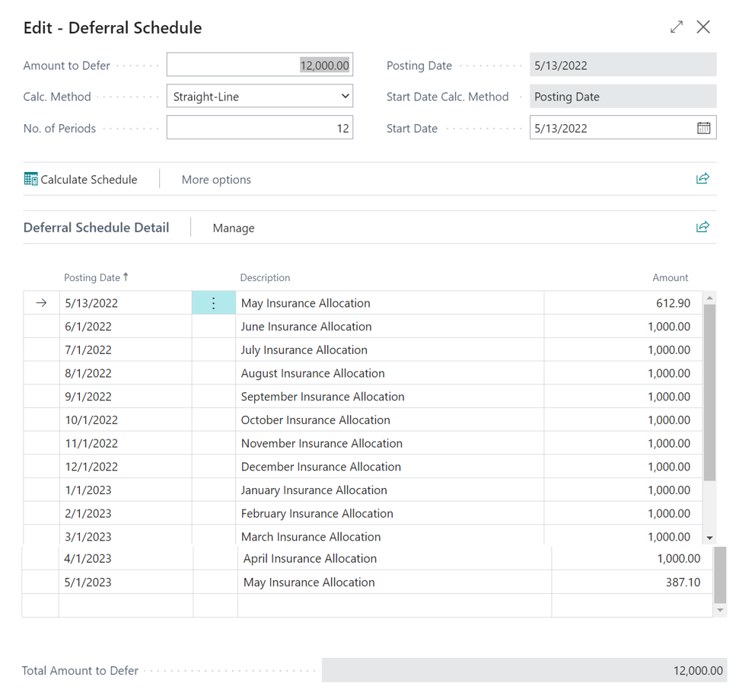
Want more information for setting up and using deferrals? Check out these two blogs
- https://kimdandnavbc.com/make-month-end-easier-use-deferrals-setups-explained/
- https://kimdandnavbc.com/make-month-end-easier-use-deferrals-transactions-explained/

