The Crazy Report Issue Gets Solved!

Kim Dallefeld, MPV, MCT, MCP

Once upon a time for a client using BC version 25.5, one report for one user would not work function properly. This is that story…..
The ACH Remittance Advice (Word format) was modified so that the Settlement Date would be part of the pdf that gets emailed.
Kay tested in Sandbox and demonstrated to the customer, who was super happy and approved the format.
After moving the new format to Production and verifying the report setups, Sally ran her first ACH process using the updated pdf. And her dismay, the detail of the invoices being paid was totally missing. Instead, the remittance looked like this:
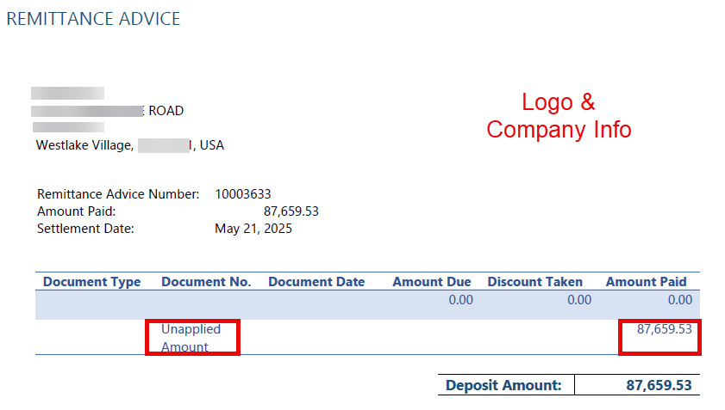
Sally wondered if she had done something wrong so she didn’t say anything. But the next time she did an ACH payment run the same thing happened; the pdf report was just wrong.
Sally told Kay that the report was not printing correctly. Kay thought something had gone wrong with the format, it was once again redone in Sandbox and tested, moved to Production, only to give Sally the same result.
What could be the issue thought Kay, Maybe the report setup had not been done appropriately. She updated the report format again, verified the report layout and report select and retested in Sandbox. Getting the correct result, Kay asked Sally to test in Sandbox. Sally tested in Sandbox two different ways: Once from Report Layouts and Once from the Payment journal and each worked. So Kay was asked to move the report to Production. Sally just knew this was fixed but when she processed her ACH Remittance Advices, she got the same old incorrect result.
Since Kay works outside of the office and Sally works in the office, the idea was floated that maybe the problem was caused with something related to their connection to the database. So John was asked to run the report under Report Layouts, not from the Payment Journal and it worked as expected.
Sally setup a Payment Journal for ACH payments, had John print the Remittance Advice and it was perfect. Problem solved right?! Nope, next time Sally ran the Remittance Advice she still got the wrong format.
What could be the issue, was it really just related to Sally. As a group they decided to ask one more person to print the Remittance Advices. So they had Becky try the Remittance Advice for the next ACH run and sure enough the pdfs were printed as desired.
So it was something related to Sally, but what….
Lots more trial and error, more head scratching, talking to MVPs, developers and about to create a Microsoft ticket when someone remembered back in NAV when you could setup which printer to use by report by user. Now this is no longer an option in BC but it did make about what could cause the report to work for 3 out of 4 users.
Here’s the solution:
In the report request page, we checked the ‘use default values from’ field. It stated ‘last used options and filters’ as shown below:
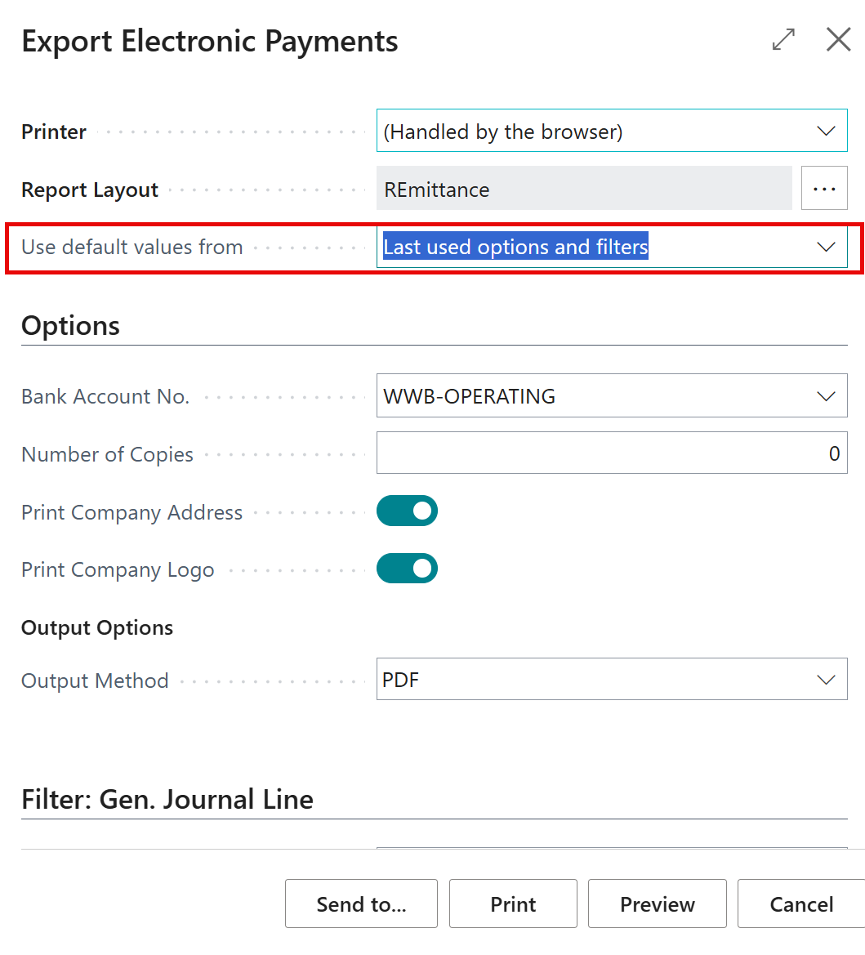
What were the options here? Having tried the drill down before, it seemed unlikely that there was anything here that would help but we looked anyway.
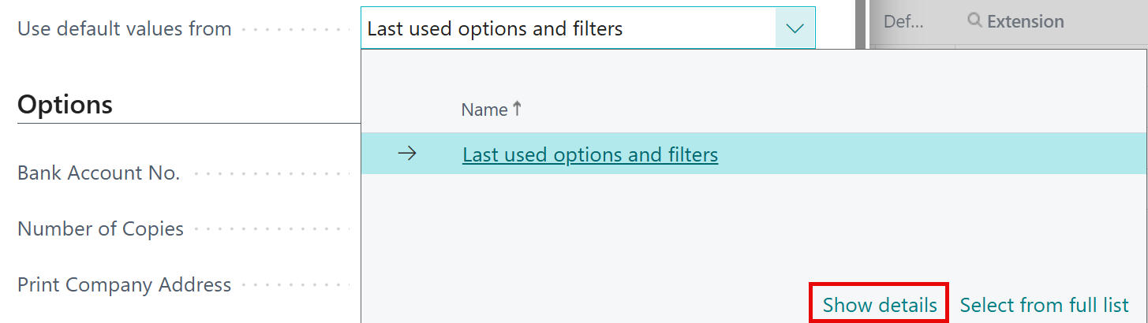

We looked into the Show Details….And there was a record for Sally. What was it doing and was it causing problems? What should we do? We collectively decided to deleted it!
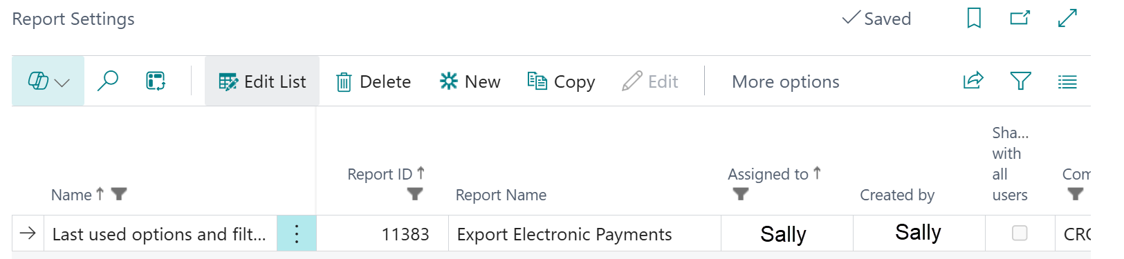

Next time Sally ran her ACH Remittance Advices, she got the report desired and we all lived happily ever after!

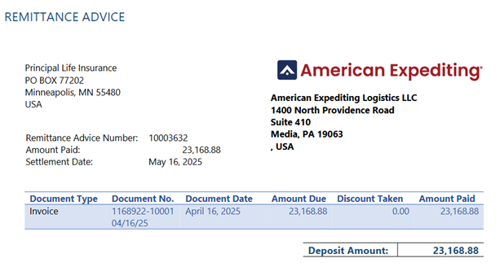
Logo &
Company Address

Vendor

Moral of the story: this could happen for any report!

