30 Problems/30 Fixes - Tip #9 Recurring Journals

Kim Dallefeld, MCP, MCT, MCP

Situation: We do accruals for sales and expenses each month but then we have to reverse them, isn’t there an easier way?
Recommendation: Recurring Journals, probably with type of Reversing Variable

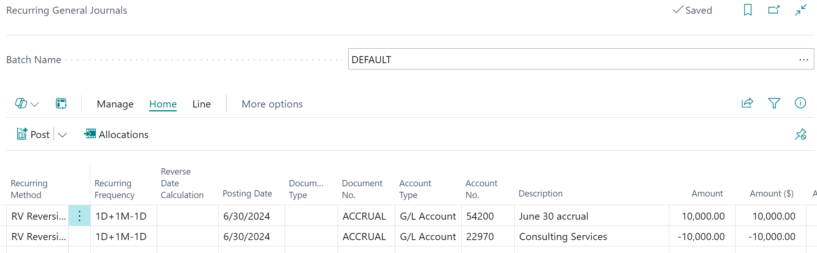

Recurring Journals have many, many options but one of the best uses is to record accruals in one month and auto-reverse in the next. The above journal would record the transaction 6/30/24 and reverse on 7/1/24. And because it is a Reversing Variable, the amounts will be cleared so that at the end of July, new amounts can be input.
Test utilizing the various features of the recurring journal in your Sandbox so that you get comfortable to the time savings that you can benefit from. I’ve only touched on a couple of small options, there are many, many more.

