30 Problems/30 Fixes - Tip #14 Statistical Accounts

Kim Dallefeld, MCP, MCT, MCP

Does your management team require financial reports to give details that are not just the amounts in general ledger accounts? Like sales per employee, gross profit per pound sold, or some other statistic?
Recommendations:
Statistical Accounts provide what you need. Yes, you need to define the accounts you require and you have to make entries to the statistical accounts for the number of employees, pounds sold, etc. Once entered and posted, financial report rows allow these values to be reported and used in calculations on financial reports.
Example of statistical accounts that have been setup. Note the Statistical Accounts Journal option, this is where you enter the values for the period.
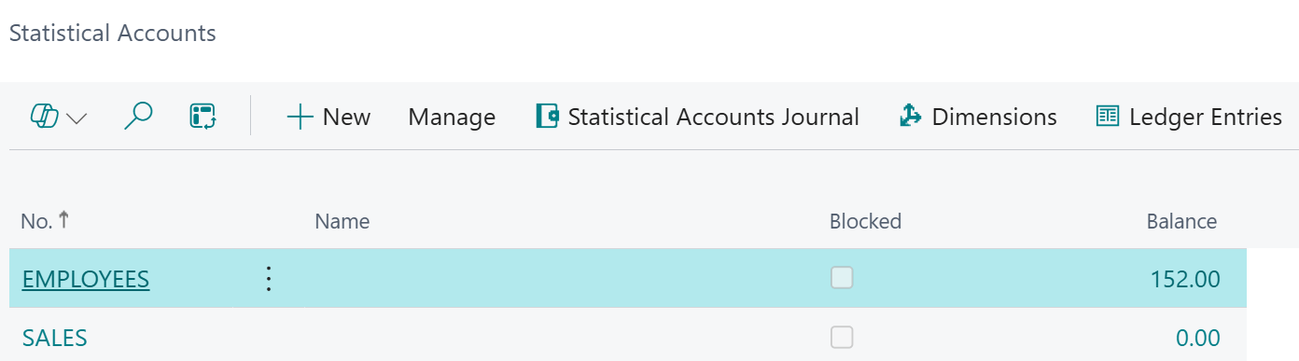
Example of adding a row to the Income Statement of number of employees.
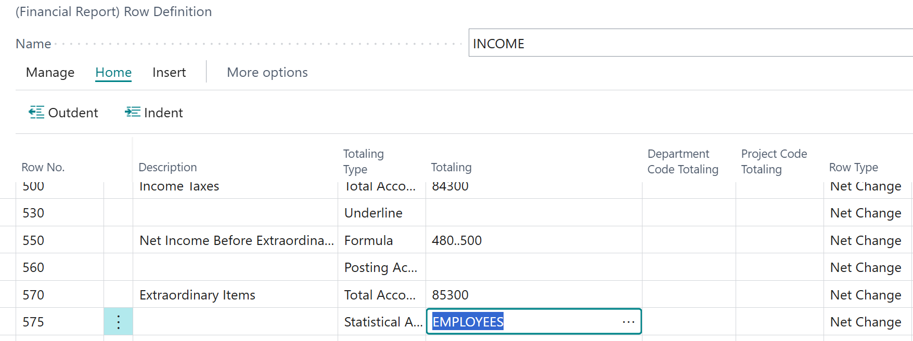
Before we had statistical accounts, we used regular general ledger accounts and had to have two accounts one for the debits and one for the offset or credits. Statistical entries do not have to be balanced as they are not accounting entries.
Give these a try when you need those calculations that you cannot get from the general ledger.

