30 Problems/30 Fixes - Tip #13 Allocation Accounts

Kim Dallefeld, MCP, MCT, MCP

Are you finding it very ‘clunky’ to breakdown expenses across departments over and over in journal entries or purchase invoices for example?
Recommendation:
Allocation Accounts solve this problem and make you more efficient in the process! You can define many allocations and how you want to distribute amounts. Doing data entry rather than choosing general ledger accounts, choose one of your allocations and let the same create all the necessary lines and calculate the amounts.

The following example is for a general journal but Allocation Accounts are also available in many places.
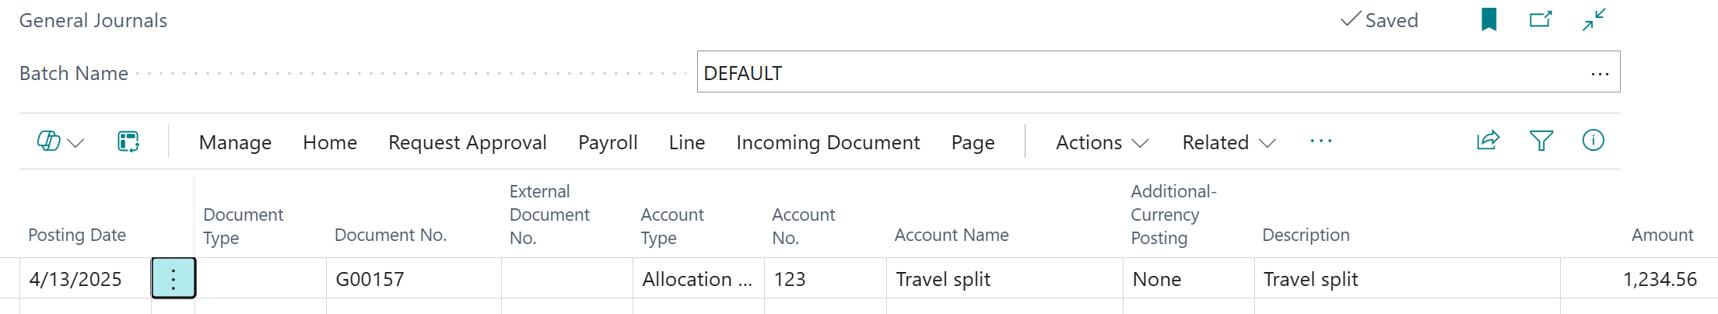
Showing the posting that is using the Allocation Accounts.
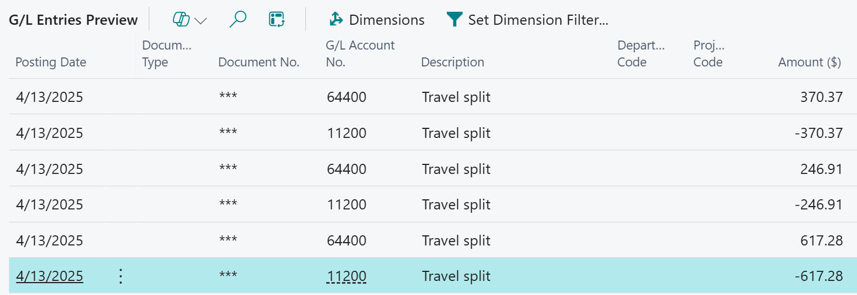
Setup of Allocation Accounts is simple. There are two types fixed and variable.
Fixed Allocation Example:
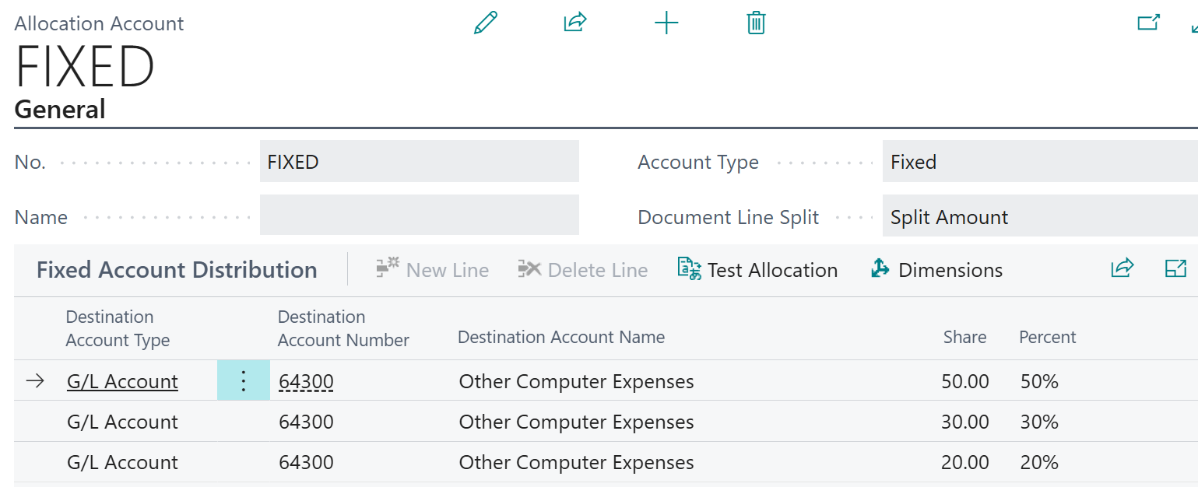
Variable Allocation Example:
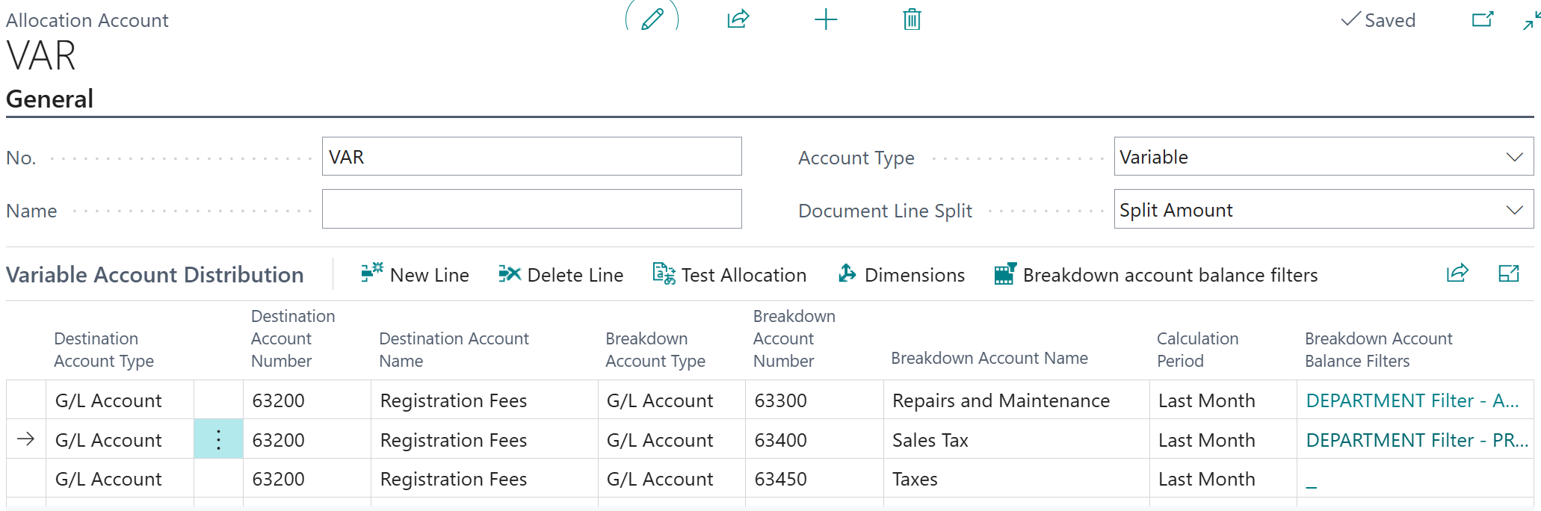
The real difference between these types is that with ‘fixed’ you define the ‘share’ or percentage allocated but with the ‘variable’ type, the share or percentage is calculated based on the number of distribution lines entered. For example: two lines it 50% to each, 3 lines is 33.33% to each, etc.
You will want to try different combinations and set the no. and name for ease of selection. Once setup, this is another time saver for your staff and more generates more consistent data.

