30 Problems/30 Fixes - Tip #11 Financial Report

Kim Dallefeld, MCP, MCT, MCP

Having trouble using Business Central Financial Reports? Feel the formats are bland or there’s \\, not enough formats? Frankly, they just need to be better?
Recommendations:
1. Learn the new features in versions 25 and 26
2. Make use of the Row and Column Definitions released for you in version 25.
3. Excel Templates are more powerful.
Did you know you can build one Excel Template to house multiple financial reports and thus create a Financial Report Workbook to reuse each reporting period?
4. New features
Negative amounts in parentheses ()
Hide rows on screen
Add beginning and ending text
Add internal notes for use
Save Excel Template to the Financial Report
Much more

Examples of financial reports added
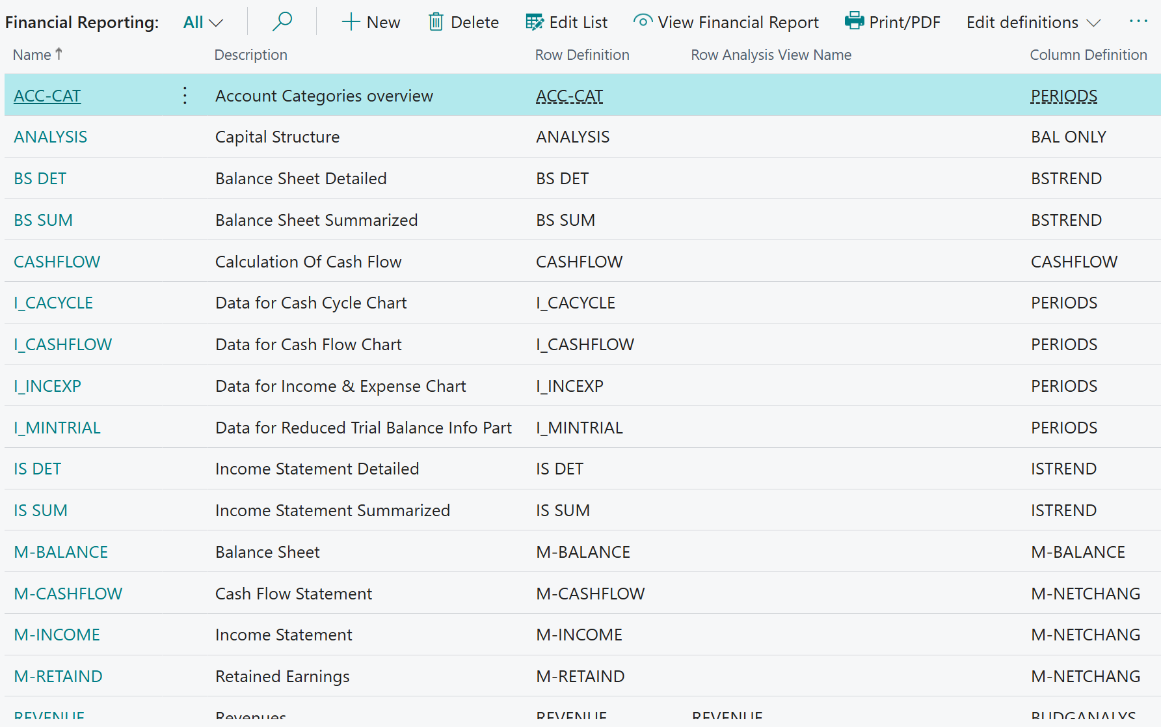

Examples of Column Definitions added:
