30 Problems/30 Fixes - Tip #8 Copy Posted Journals

Kim Dallefeld, MCP, MCT, MCP

Situation: Your Controller asks “Posted General Journals is a page but we have no data, why?”
The answer is simple, BC is not setup to create the copy!
Recommendations:
1. By default all new companies have the ‘copy posted journals’ setup for some journals
2. Versions 25 and greater have the feature but it must be turned on.

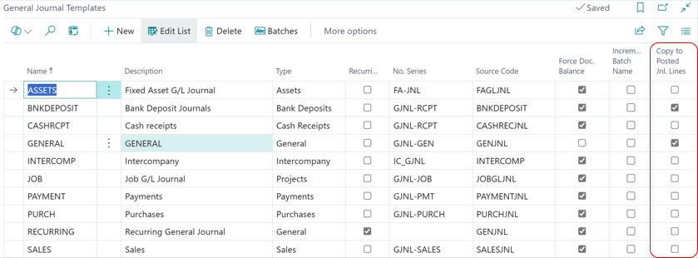

To use the copied journals, search for Posted General Journals and you will find options to copy selected lines to a journal and copy G/L Register to a journal. What’s great about these features is the ability to change the posting date and the sign of the entries.

