30 Problems/30 Fixes - Tip #7 Invoice Posting Control

Kim Dallefeld, MCP, MCT, MCP

Situation: Permissions are all setup. Sales, purchase and service invoice postings are restricted but still need some users to be able to post just invoices. Permissions seem lacking to control this.
Recommendation: User Setup has three fields to help, one for sales invoices, one for purchase invoices and one for service invoices.
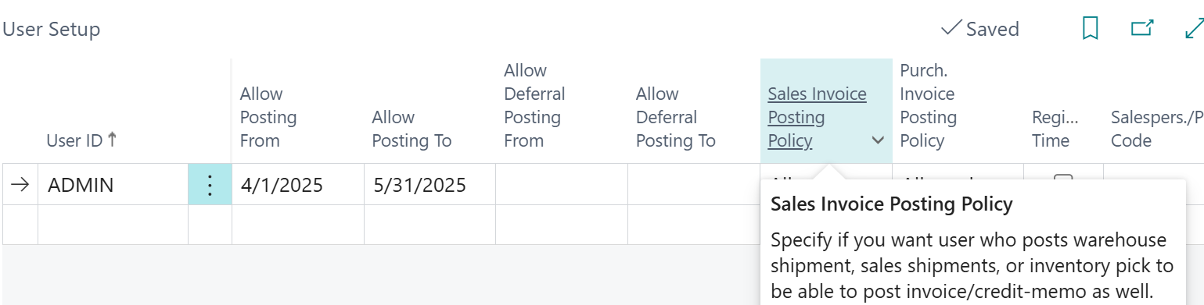
Options for Invoice Posting Policy:
Prohibited – user cannot post invoice
Allowed – user can post invoice
Mandatory – user is required to post invoice
Super easy way to control user ability to post invoices.

