30 Problems/30 Fixes - Tip #6 Templates

Situation: Customers, Vendors and Items are not being created accurately by staff.
Recommendation: Use Templates!
Templates allow the pre-definition of settings for types of customers, vendors and items so that the desired fields are setup consistently and accurately.
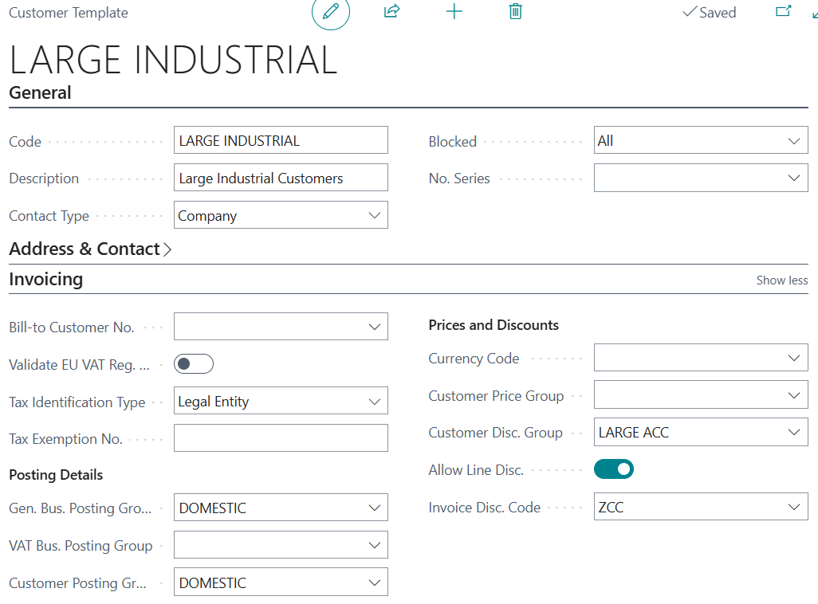
This may not solve all your problems with master record creation but it can certainly help.
Another suggestion is to use the ‘blocked’ field and set to ‘all’ as shown above. Then have a Workflow setup to remove the blocked setting once the workflow or master record is approved.

