# 30 Problems/30 Fixes - Tip #5 Posted GL Description

Problem: Accounts Payable is entering details on the lines of purchase invoices but they never show up in GL

Staff is working hard and reaping no rewards for the business!

Recommendation:

Purchase & Payables Setup’s field Copy Line Descr. to G/L Entry should be ‘toggled’ on!

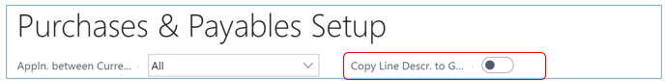

This will provide better, more applicable descriptions for your general ledger transactions.