30 Problems/30 Fixes - Tip #4 External Document No.
Problem: BC let you post a vendor invoice number more than once!
How can this happen and how can it be stopped?
Recommendation:
Purchases & Payables Setup’s field Ext. Doc. No Mandatory should be ‘toggled’ on.
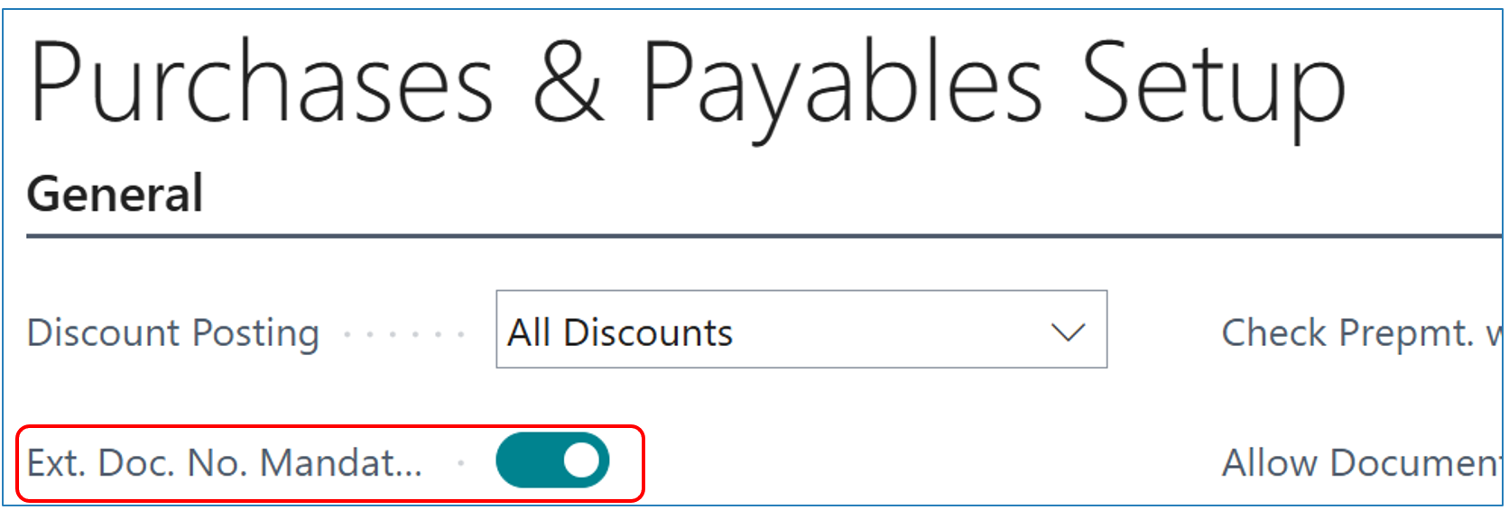

Tip: See Tip #3 for when you need to post the same invoice number but it’s a correction…..if you have posted an invoice with the correct PO number but for some reason have credited it off and need to post a new invoice with the vendor’s invoice number that you already used. BC will not let you use the same external document number again (the same vendor invoice). The work around…the number must be unique and a simple period ‘.’ at the end makes the number unique.

