30 Problems/30 Fixes - Tip #3 External Document No.
Problem: Your organization requires that ALL customer orders have a Customer PO number!
What setting will help you accomplish this task?
Recommendation:
Sales & Receivable Setup’s field Ext. Doc. No Mandatory should be ‘toggled’ on.
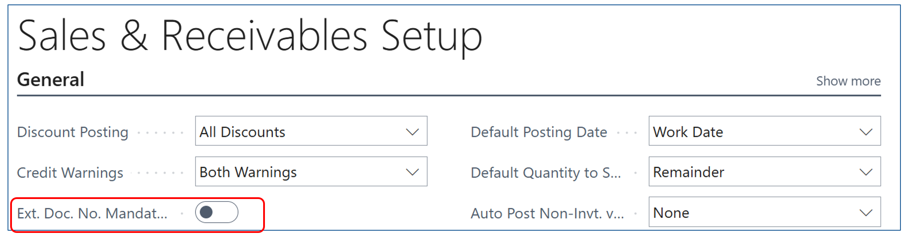

Tip: you can run into a problem if you posted an invoice with the correct customer PO number but for some reason you have to credit it off and post a new invoice for the same customer PO number . BC will not let you use the same external document number again (the same customer PO.) The work around…the number must be unique and a simple period ‘.’ at the end makes the number unique.

