30 Problems/30 Fixes - Tip #2 Default Posting Date
Problem: Sales Order booked in February finally shipped in April, but recorded as February.
Why did this happen? Posting Date on the order defaults to either today or work date when the sales order is created AND the user did not update when posting the shipment.
Recommendations:
Control User Setup Allow Posting Dates or General Ledger Setup Allow Posting Dates
AND/OR
Sales & Receivable Setup default Posting Date set to none thus forcing the user to enter a date.
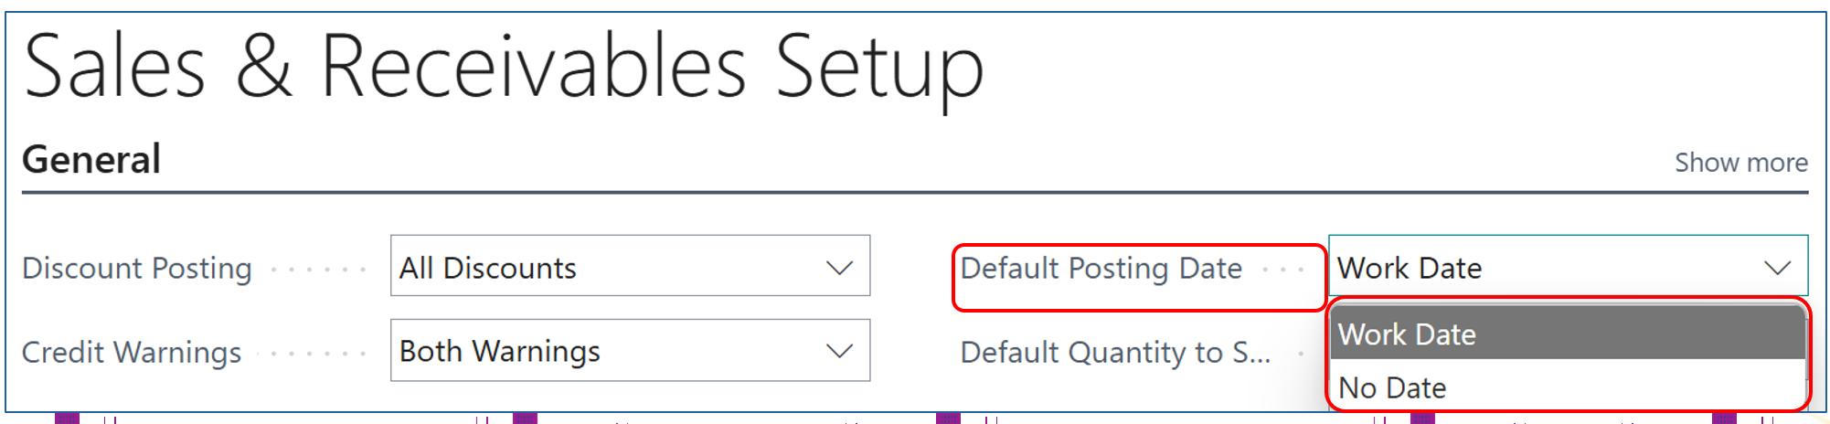

Simple fix and highly recommended. If the posting date is left blank the user cannot post without populating the field.
And by controlling you General Ledger Setup and User Setup allow posting from/to dates, the wrong posting date can be avoided.

